

**data commuication and networks**

**LAB - 3**



**October 9, 2022**

**MUHAMMAD NOMAN**

**35152-BSCS**

**TASK – 1**

**DHCP , DNS, HTTP**

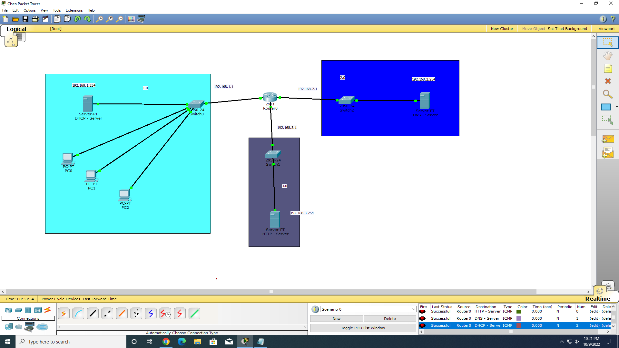

**ROUTER CONFIG**

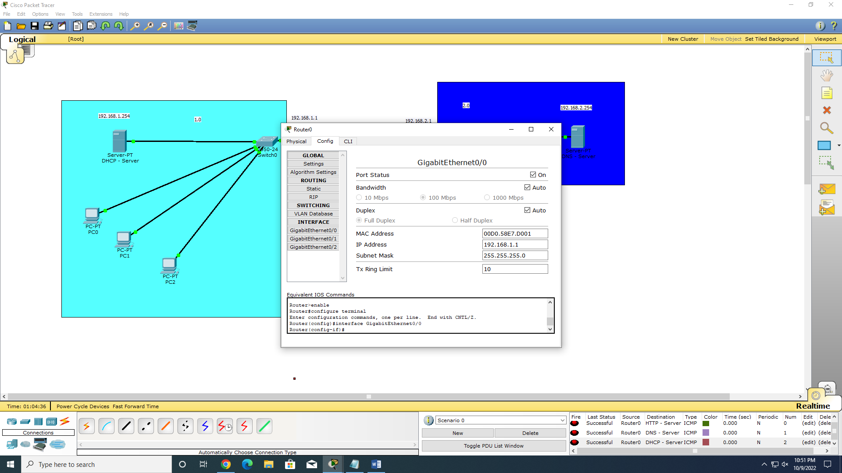

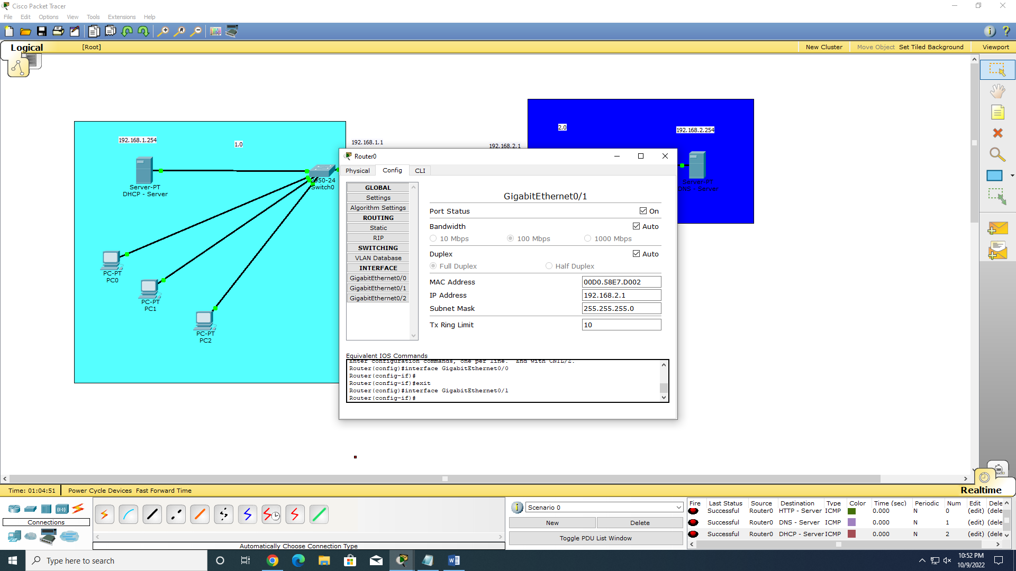

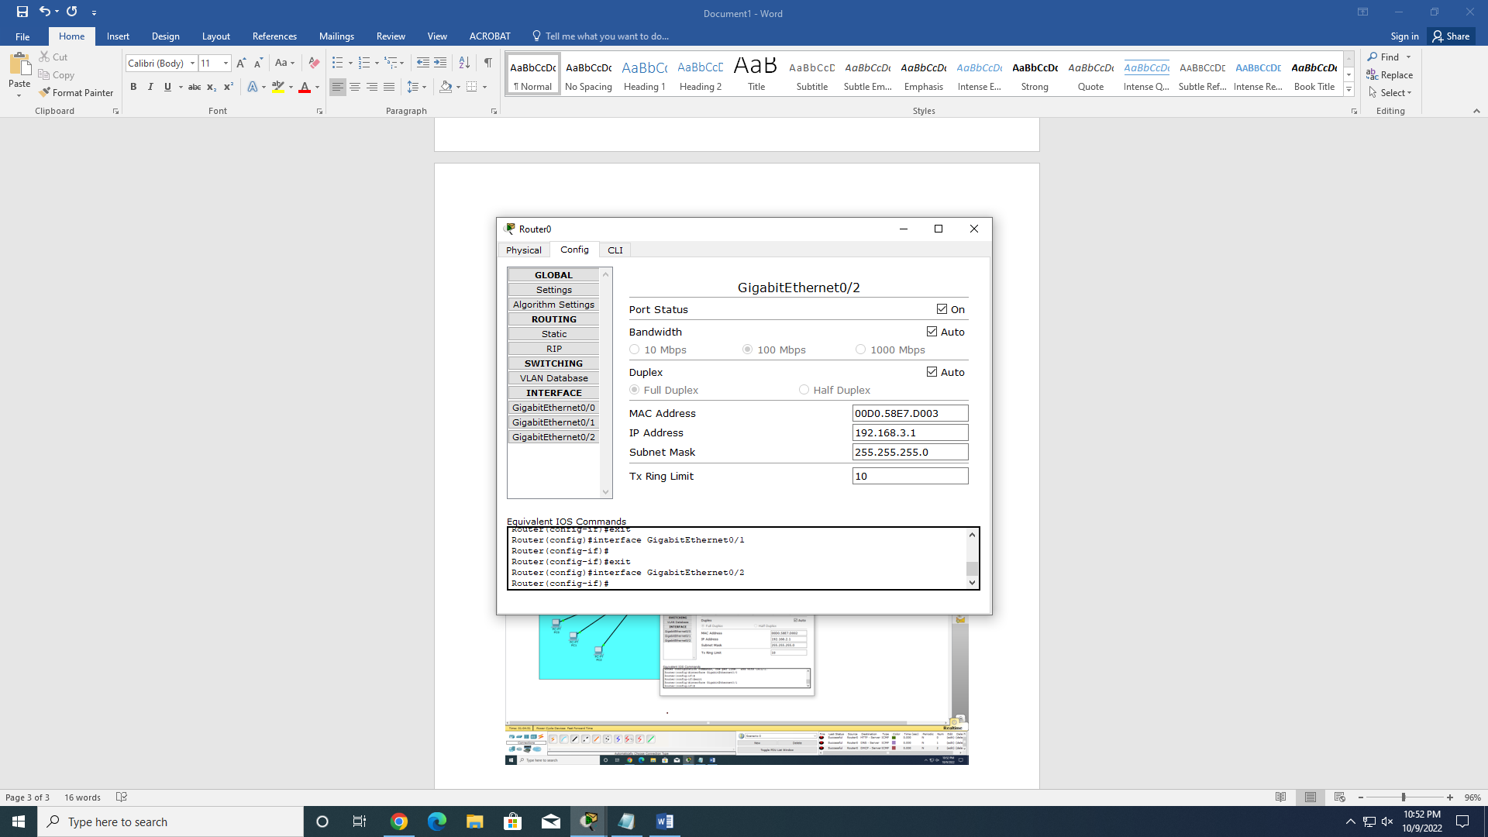

**DHCP CONFIG:**

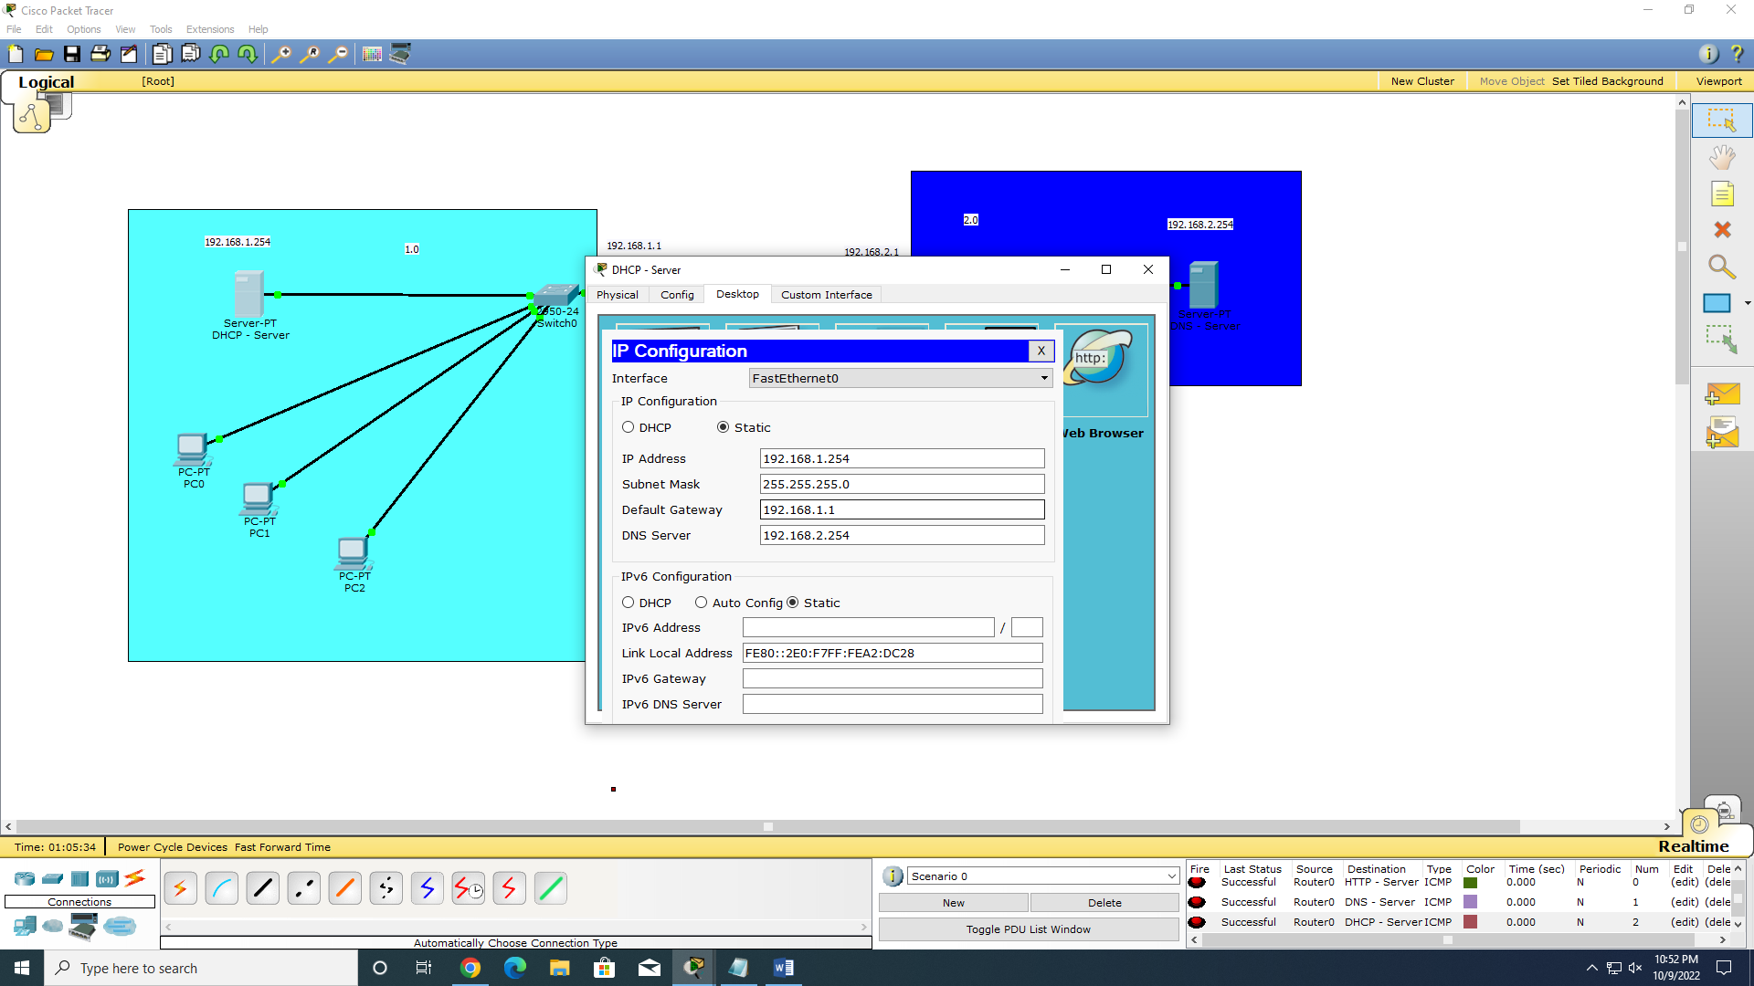

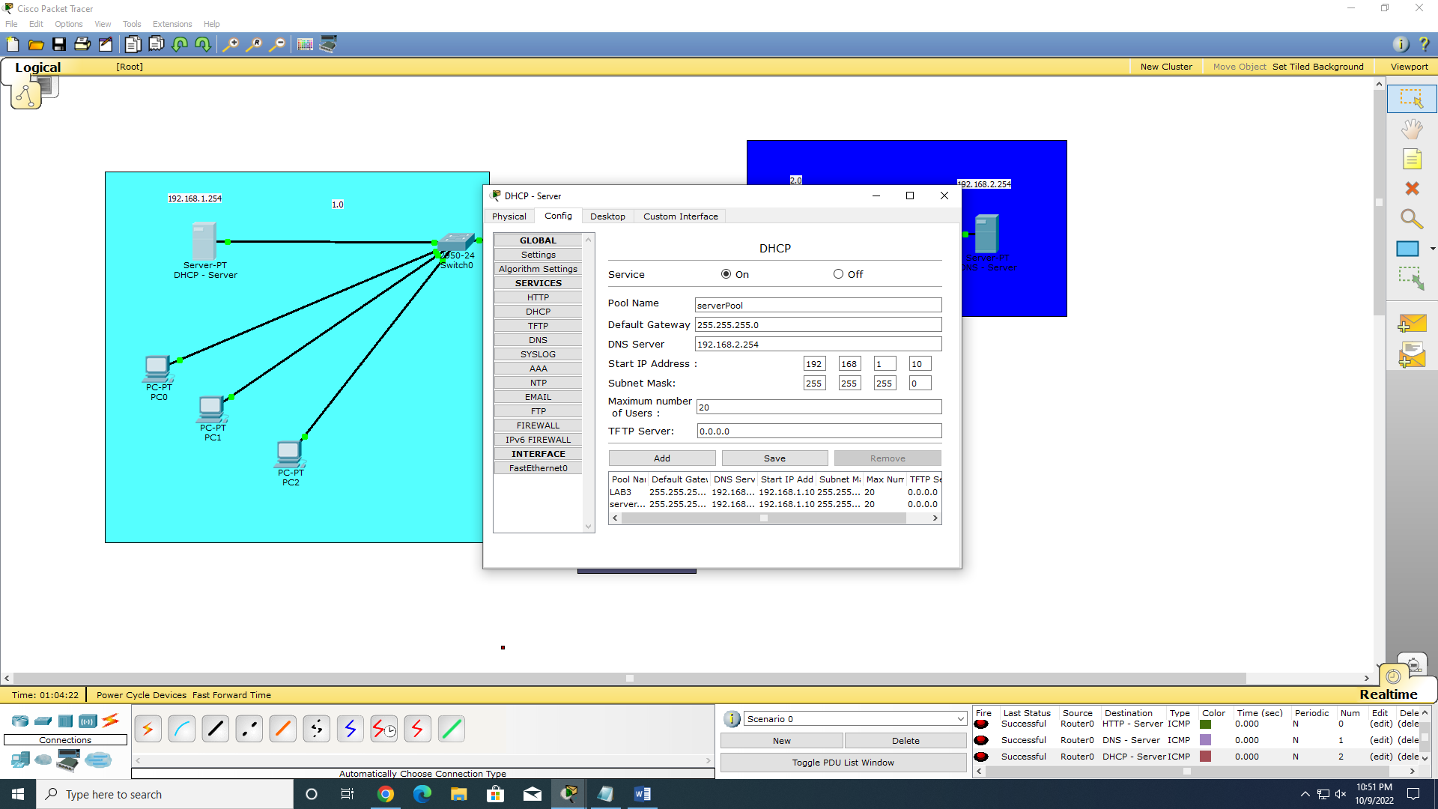

**DNS SERVER CONFIG:**

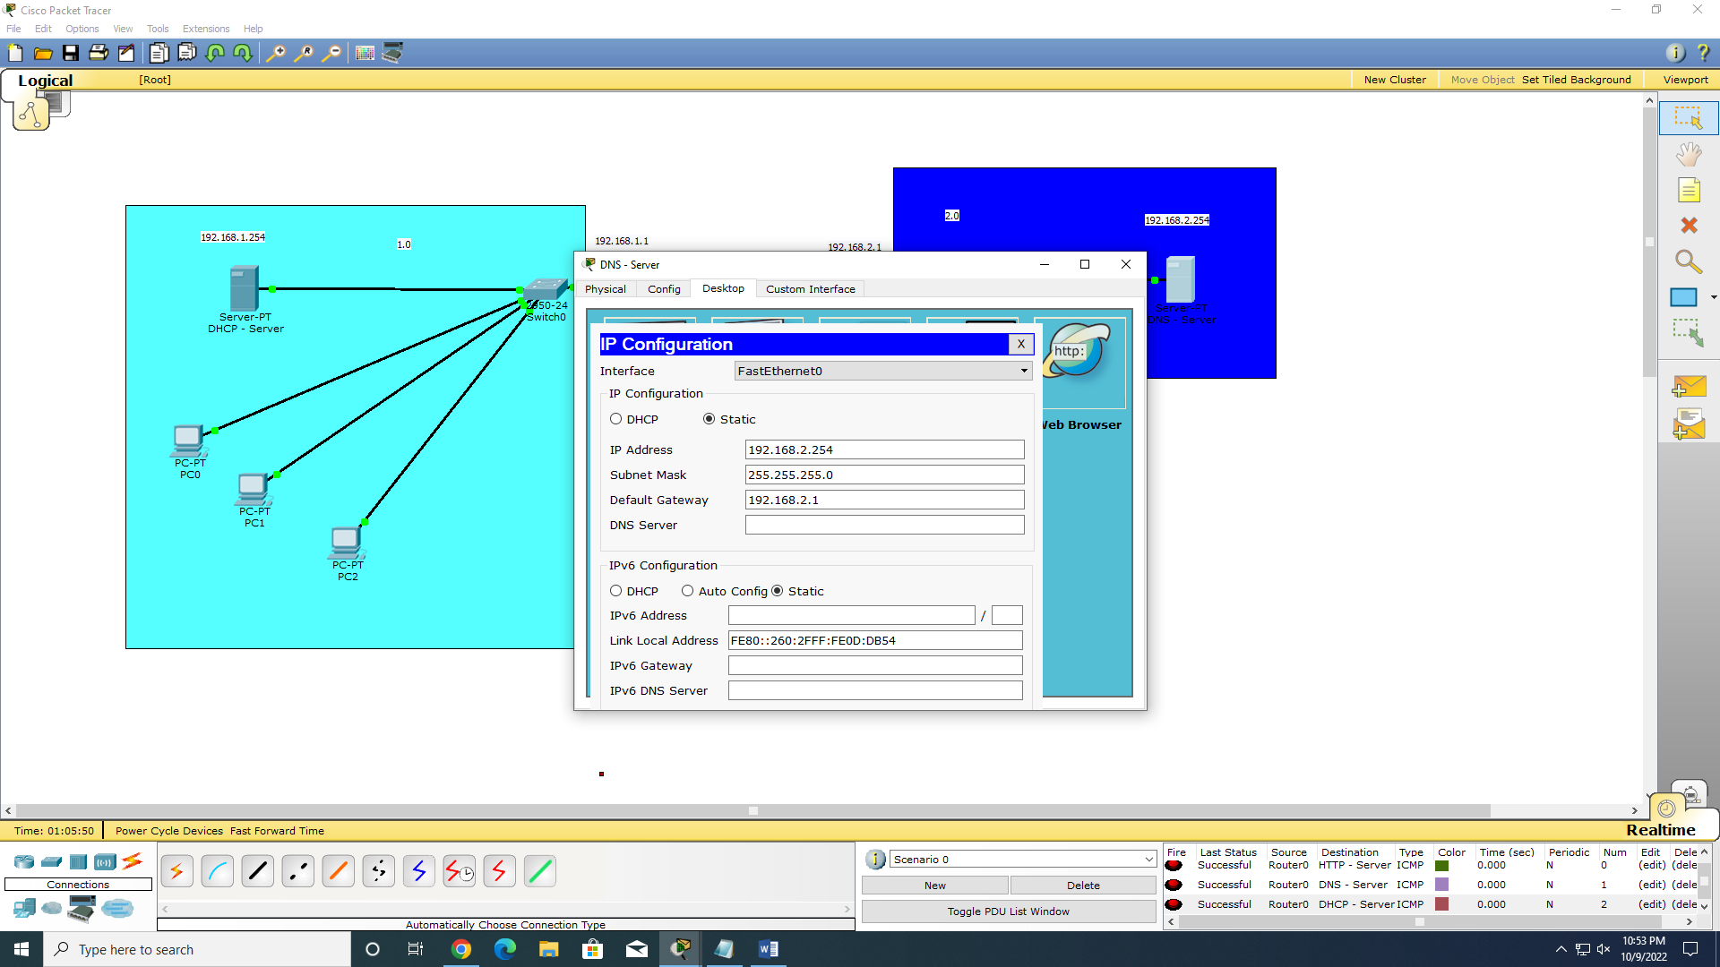

**HTTP SERVER CONFIG:**

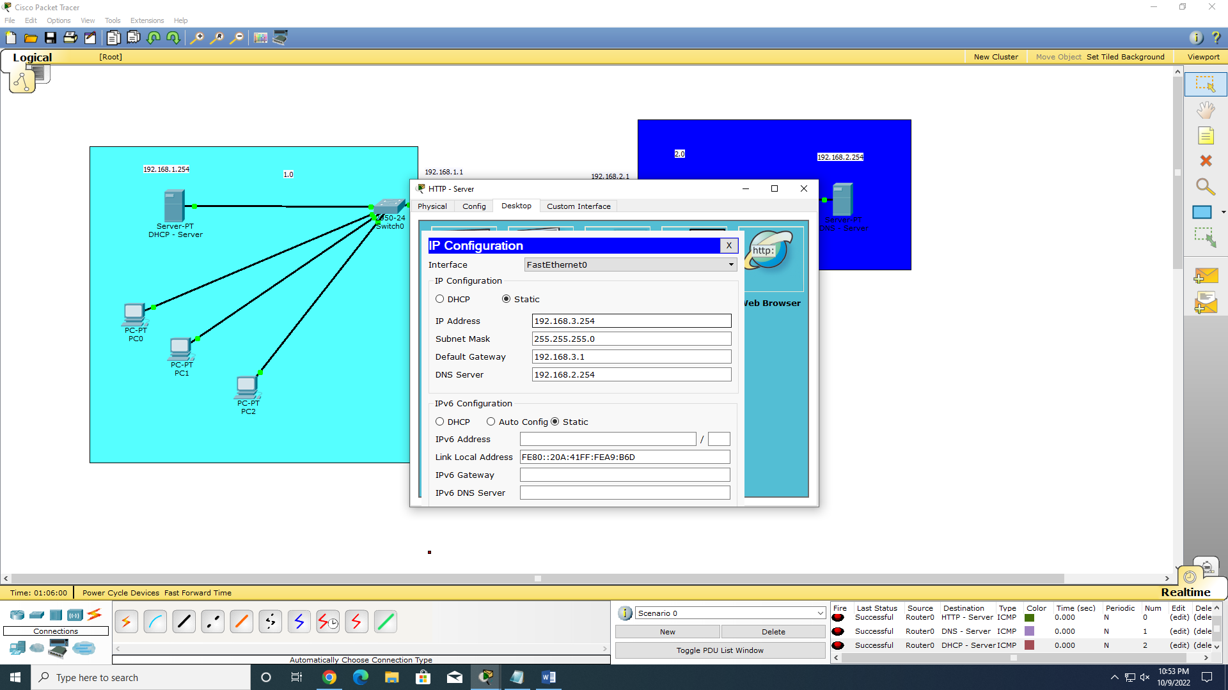

**SYSTEM CONFIG USING DHCP:**

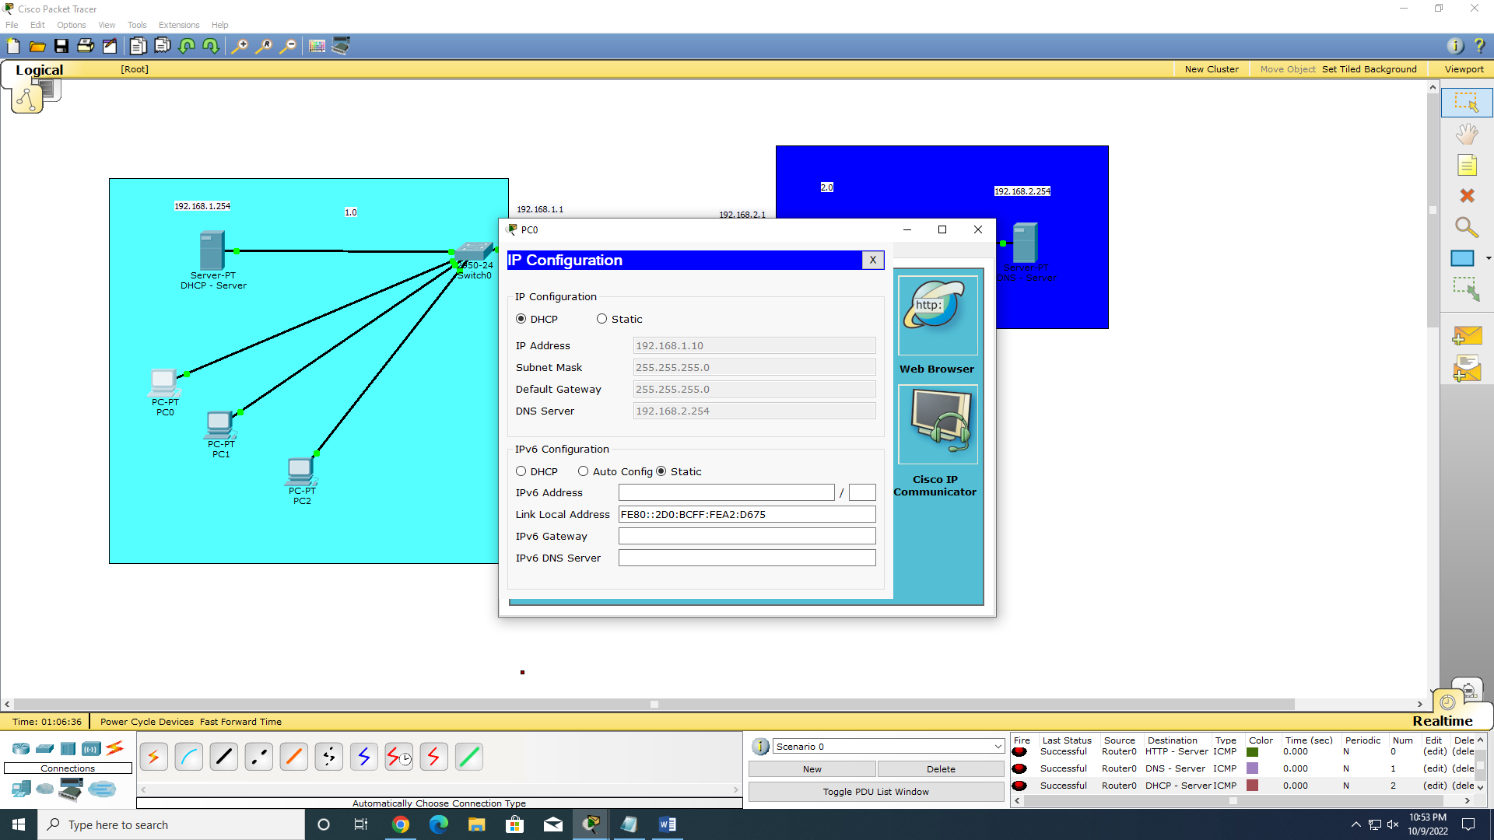

**PACKETS DROPPING:**

